# General Instructions

The web site at the link shown below contains a number of different files with information relating to Australian labour force statistics from 1978 through to 2017. You are to configure Power BI desktop so that it can connect to this website and import all of the tables from 4 through to 11. Make sure that you DO NOT manually download the files and then import into Power BI. Power BI should dynamically, on data refresh, connect to the URL below and download the files.

<http://www.abs.gov.au/AUSSTATS/abs@.nsf/DetailsPage/6202.0Jul%202017?OpenDocument>

This should be done in an efficient manner using a Power query function. You should create one parameterized function that is capable of importing the given file format. You should then loop through a list of the 7 data items required and call the afore mentioned function for each.

Also import the information contained in the file titled “14100DS0004_2017-03.xlsx” this file should have been provided to you as part of zip file.

The final set of files that you are required to import should also reside in the Zip file provided and all begin with “LGA_2013”. Import all of these files in a single power query operation (hint: Power BI Desktop can automatically combine all files within a single folder).

At a minimum, you are required to create the visual elements shown in the figures 1 through to 4 (See next page). Feel free to extend on this by adding any other elements that you think may be interesting.

# Further Direction and Hints

* When importing the labour statistics data be sure to import ALL of the data columns. You should be able to find a way to automatically apply descriptive names each of the columns of incoming data. The resulting table in your model should look something like this (with a lot more columns!)

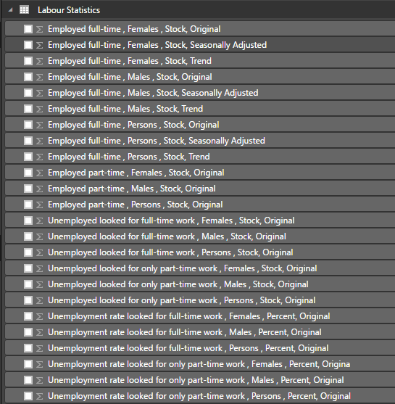

* Cross check your output with the samples provided in this document. Multiple sample screenshots have been provided to allow you to validate your output using a variety filters and perspectives.

Figure 1: Initial View

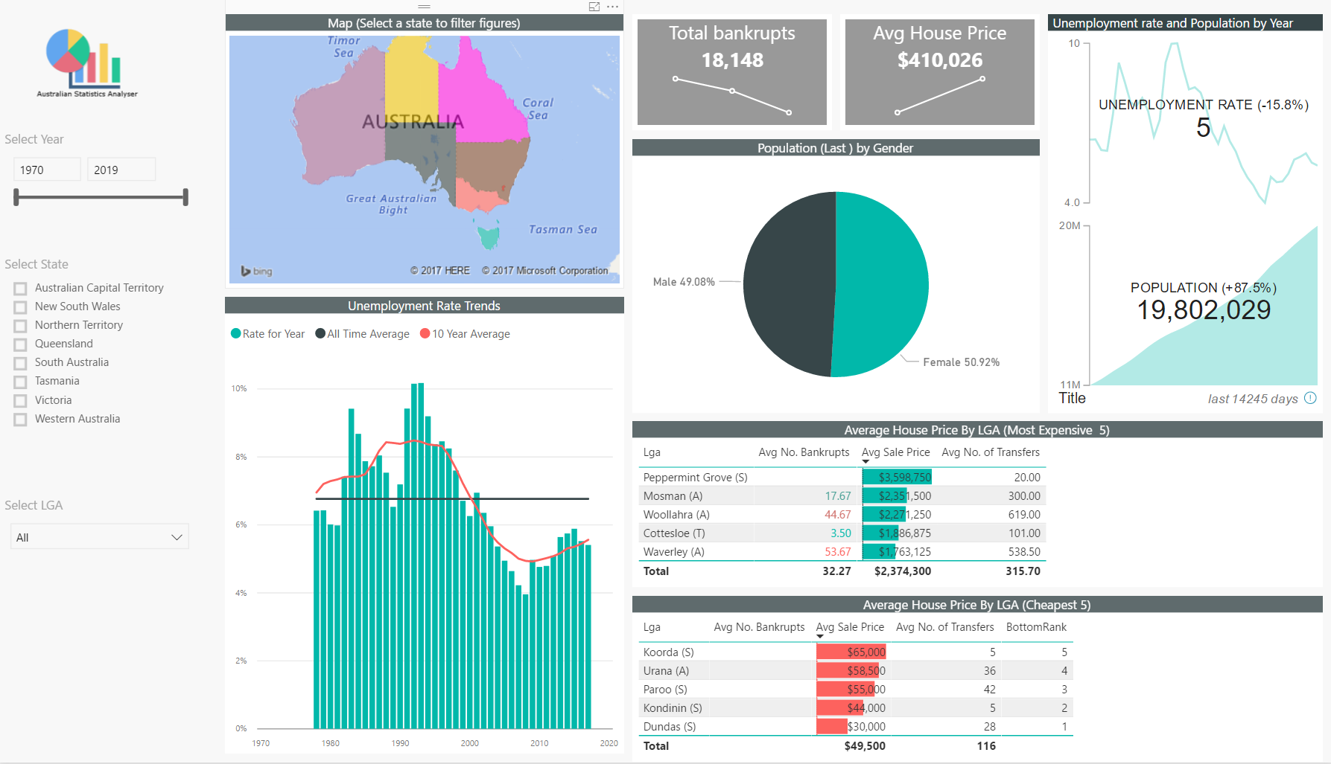

Figure 2: Western Australia Selected on the map

Highlight the cross-filtering of visuals and the semi-additive measure for population

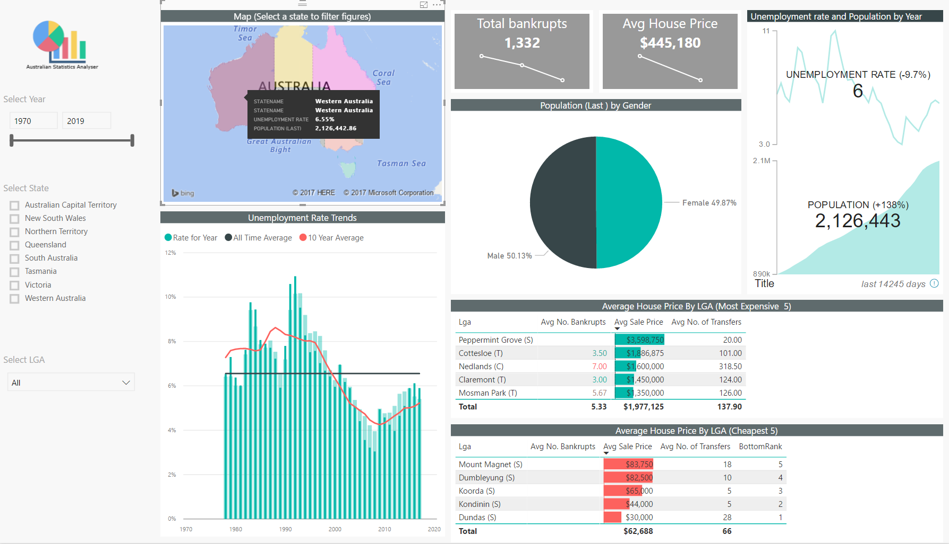

Figure 3: 2014 Selected on the column chart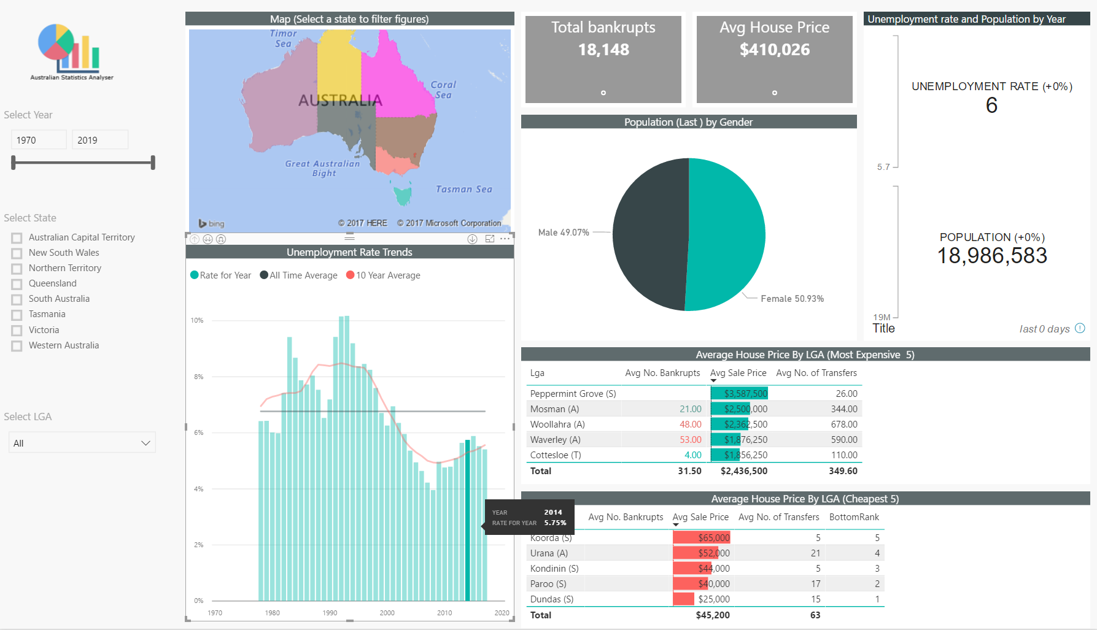

Figure 4: Tasmania Selected on the slicer

